SESSION 1 LAB EXPERIMENT
EXP 4: Equal Elements and Product Divisible by K
#include <stdio.h>

int main() {
int n, k;
int nums[100];
int count = 0;

printf("Enter size of array: ");
scanf("%d", &n);

printf("Enter array elements:\n");
for (int i = 0; i < n; i++) {
scanf("%d", &nums[i]);
}

printf("Enter k: ");
scanf("%d", &k);

for (int i = 0; i < n; i++) {
for (int j = i + 1; j < n; j++) {
// Check both conditions:
// 1. nums[i] == nums[j]
// 2. (i * j) is divisible by k
if (nums[i] == nums[j] && (i * j) % k == 0) {
count++;
}
}
}
printf("Number of valid pairs = %d\n", count);
return 0;
}
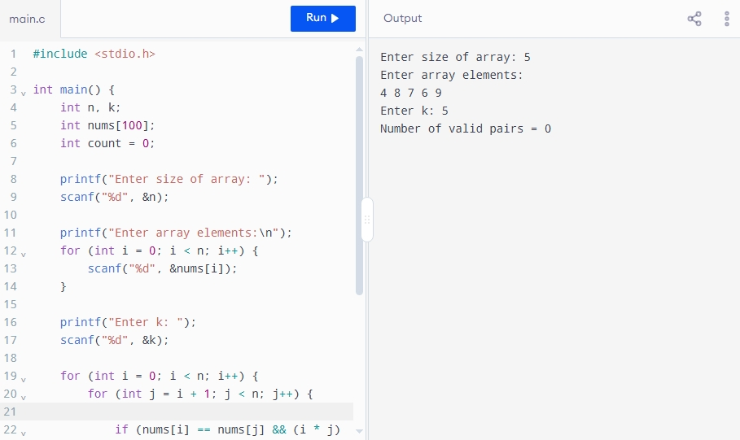

Time Complexity = O(n²)
Space Complexity = O(1)

